Managing Sales, Purchases, Internal Transfers and Reporting Across Multiple Companies and Branches in Odoo 19
Rohan Raj | Feb 23, 2026
This document explains how to manage daily operations in Odoo 19 when the business has multiple companies, branches and warehouses. It covers creating sales orders from specific warehouses, receiving purchases at specific warehouses, transferring stock between warehouses (manually and automatically), linking companies so that a sales order in one company automatically creates a purchase order in the other, and viewing separate financial reports for each company and branch.

Understanding the Setup
In Odoo 19, businesses can be structured in different ways depending on their legal and operational needs. The three main building blocks are companies, branches and warehouses.
Company — A separate legal entity with its own GSTIN (or Tax ID), chart of accounts, bank accounts and financial statements. Each company files its own tax returns and maintains its own books. A business group with two different GSTINs needs two separate companies in Odoo.
Branch — A subdivision within a parent company that shares the same GSTIN and chart of accounts. Branches are useful for tracking performance of different offices or divisions without maintaining fully separate books. In Odoo 19, child companies under a parent company serve as branches.
Warehouse — A physical location where inventory is stored. Each warehouse belongs to exactly one company. A company can have multiple warehouses (for different stores, factories or storage facilities). Stock is tracked separately at each warehouse.
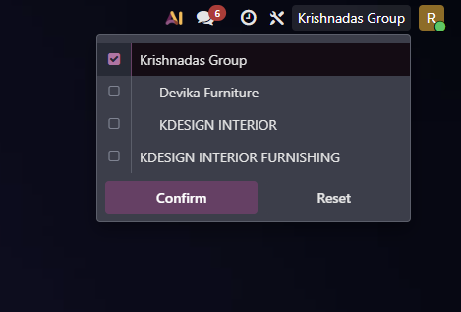
The company selector in the top right corner of the screen allows switching between companies and branches. When a company/branch is selected, all operations, reports and data are filtered to that company/branch only.

Part 1 — Creating a Sales Order from a Specific Warehouse
When a customer places an order, the business needs to select which warehouse will fulfil the delivery. This ensures goods are shipped from the correct location and stock levels are updated at the right warehouse.
To create a sales order, open the Sales application and click New. Select the customer, then add the products and quantities required. Before confirming the order, look for the Warehouse field under other info tab. This field determines which warehouse the goods ship from. Click the Warehouse field and select the appropriate warehouse from the dropdown list.
Sales App → New → Select Customer → Add Products → Change Warehouse → Confirm
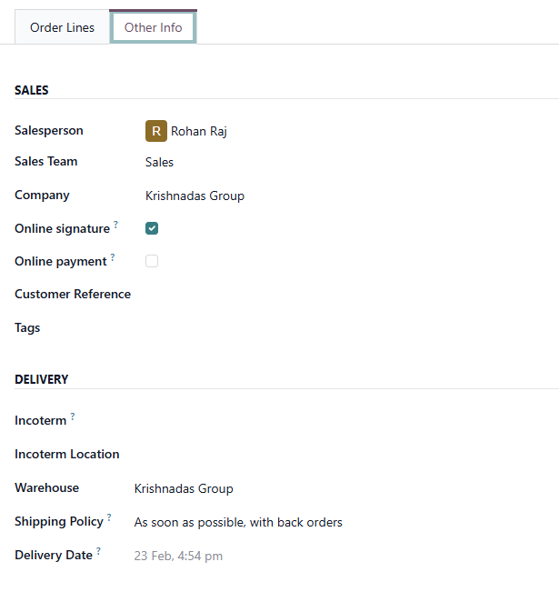
Once the order is confirmed, Odoo automatically creates a delivery order from the selected warehouse. The invoice is generated under the company that owns the warehouse.

Part 2 — Creating a Purchase Order for a Specific Warehouse
When goods are purchased from a vendor, they can be received directly into any warehouse. This avoids the need to receive everything at headquarters and then transfer.
To create a purchase order, open the Purchase application and click New. Select the vendor, then add the products and quantities. On the purchase order form, locate the Deliver To field. This determines which warehouse receives the incoming goods. Click on this field and select the destination warehouse.
Purchase App → New → Select Vendor → Add Products → Change Deliver To → Confirm Order
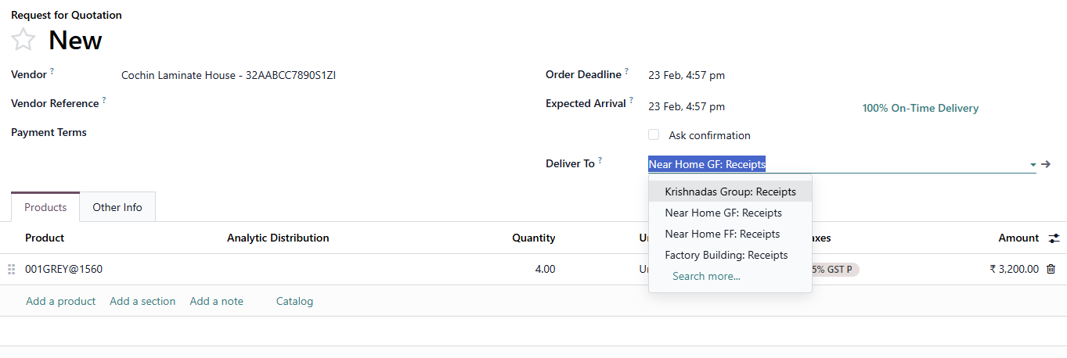
Purchase order form with the Deliver To field highlighted showing the destination warehouse selection
After the order is confirmed, a receipt is created at the selected warehouse. When the goods arrive, open the receipt and click Validate to confirm that the products have been received.

Part 3 — Transferring Stock Between Warehouses (Same Company)
When stock needs to move from one warehouse to another within the same company, an internal transfer is used. Since both warehouses belong to the same company, this is a simple stock movement with no tax, no invoicing and no accounting entries.

Method 1 — Manual Internal Transfer
To create a manual transfer, navigate to the Inventory application. Go to Operations and select Internal. Click New to create a new transfer. Select the Source Location and the Destination Location, add the products and quantities, then click Validate when the goods are physically moved.

Inventory App → Operations → Internal → New

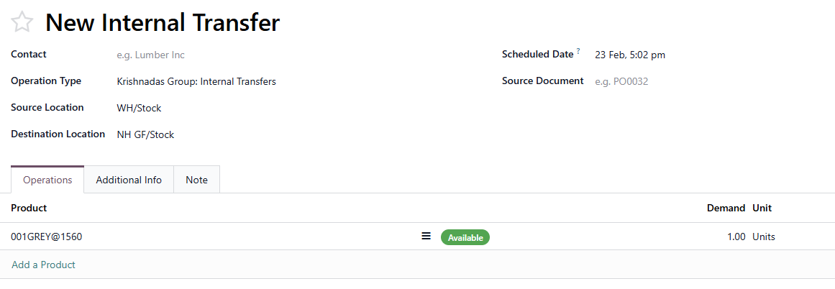
Internal transfer form showing source location and destination location

Method 2 — Automatic Resupply Between Warehouses
Instead of creating manual transfers each time, Odoo can be configured to automatically move stock from a supply warehouse to a branch warehouse whenever stock runs low. This requires three steps: enabling multi-step routes, configuring resupply on the warehouse, and creating reordering rules.

Step 1 — Enable Multi-Step Routes
Inventory App → Configuration → Settings → Warehouse section → Enable Multi-Step Routes → Save

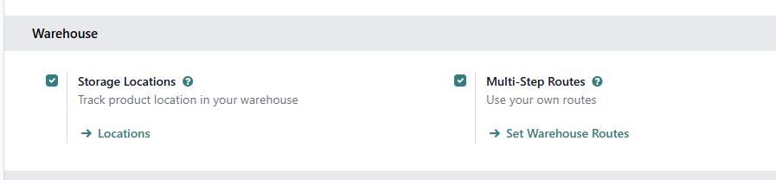
Inventory settings showing the Multi-Step Routes checkbox enabled in the Warehouse section

Step 2 — Configure Resupply on the Branch Warehouse
Open the branch warehouse from the warehouse configuration screen. In the Resupply From field, check the box next to the warehouse that should supply this branch. Save the changes.

Inventory App → Configuration → Warehouses → Select the warehouse
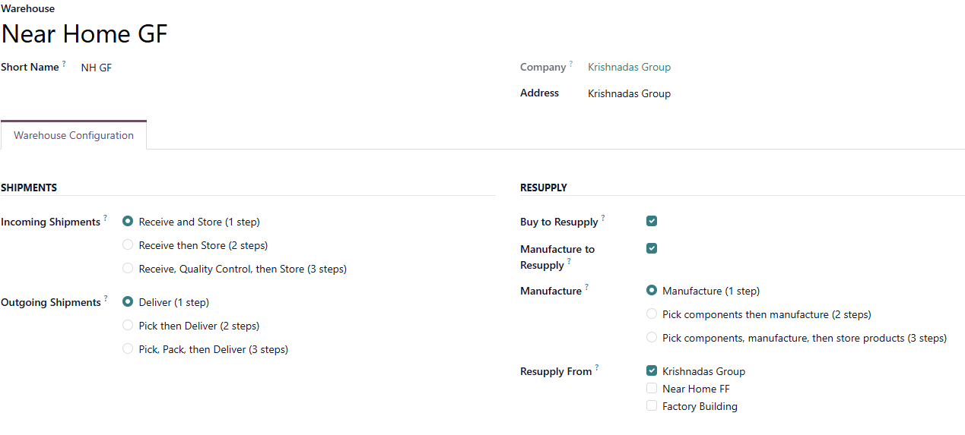
Warehouse configuration showing the Resupply From field with the supply warehouse selected
Repeat this for any other warehouse that should be automatically resupplied.
Step 3 — Create Reordering Rules
Reordering rules tell Odoo when to trigger the automatic transfer. For each product at each warehouse, set the minimum quantity (trigger level) and maximum quantity (target level).
Inventory App → Operations → Replenishment → New
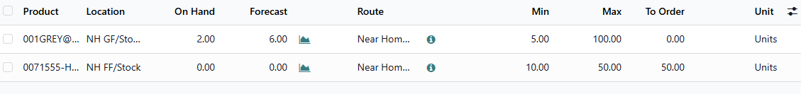
Reordering rules showing product along with its resupply route

Part 4 — Transferring Stock Between Companies or Branches
When stock needs to move between different branches or companies, there are two methods available in Odoo 19. The method you choose depends on whether the entities are branches under the same parent company or completely separate legal entities with different GSTINs.

Method 1 — Internal Transfer via Inter-Company Transit (For Branches)
When branches share the same parent company (same GSTIN/Tax ID), stock can be transferred using a simple internal transfer through the Inter-company transit location. This is a built-in location in Odoo that has no company assigned to it, making it accessible by all companies and branches. This method requires no sales order, no purchase order, no invoice and no tax. Products move at their existing cost price with zero financial impact.
How It Works
The transfer happens in two steps. First, the sending branch creates an internal transfer from its warehouse stock location to the Inter-company transit location. Second, the receiving branch creates an internal transfer from the Inter-company transit location to its warehouse stock location.
Transfer Flow:
Branch A Warehouse → Inter-company Transit → Branch B Warehouse
Step 1 — Send from Source Branch
Switch to the sending branch using the company selector. Open the Inventory application, go to Operations and select Internal Transfers. Click New. Set the Source Location to the branch warehouse stock location (for example WH/Stock). Set the Destination Location to Inter-company transit. Add the products and quantities. Click Validate.
Inventory App → Operations → Internal Transfers → New → Source: WH/Stock → Destination: Inter-company transit → Add Products → Validate
Step 2 — Receive at Destination Branch
Switch to the receiving branch using the company selector. Open the Inventory application, go to Operations and select Internal Transfers. Click New. Set the Source Location to Inter-company transit. Set the Destination Location to the receiving branch warehouse stock location (for example DF/Stock). Add the same products and quantities. Click Validate.
Inventory App → Operations → Internal Transfers → New → Source: Inter-company transit → Destination: DF/Stock → Add Products → Validate
Key Points About This Method:
No journal entries are created when products use periodic (manual) valuation, which is the default. Product sale price and cost price remain exactly the same after the transfer. The Inter-company transit location is automatically created by Odoo when multi-company is enabled. It has no company assigned (company field is empty), which is why both branches can access it. After the transfer, the transit location should show zero quantity as all goods have moved to the destination.
When to Use This Method:
Use this method when transferring stock between branches that share the same parent company and the same GSTIN. Since branches are subdivisions of the same legal entity, there is no legal requirement to create sales and purchase documents between them. This is similar to moving goods between two shelves or two stores of the same business.

Method 2 — Inter-Company Transactions via SO/PO (For Separate Legal Entities)
When the entities are separate legal entities with different GSTINs, the transfer must be treated as a sale from one company and a purchase by the other. This is required by law because each entity files its own tax returns and must maintain proper documentation for goods movement between them.
Setting Up Automatic Inter-Company Transactions
Step 1 — Enable Inter-Company Transactions
Open the General Settings and enable the inter-company feature.
Settings → General Settings → Inter-Company Transactions → Enable → Save
Step 2 — Configure Rules for Each Company
Switch to each company using the company selector and configure the inter-company rules in the settings. The following options can be configured for each company:
Step 3 — Set the Purchase Journal, Warehouse and Operation Type for Auto-Generated Orders
In the inter-company settings, set the Purchase Journal, Use Warehouse and Use Operation field for each company. This determines which purchase journal, warehouse and operation type is used when Odoo auto-generates a purchase order or sales order in that company.
When a sales order is confirmed in Company A with Company B as the customer, Odoo automatically creates a corresponding purchase order in Company B with Company A as the vendor. The delivery, receipt and invoicing follow the standard process in each company.

Manual Method (Without the Inter-Company Module)
If the inter-company module is not enabled, the same result can be achieved manually. Create a sales order in Company A with Company B as the customer. Then switch to Company B and create a purchase order with Company A as the vendor, adding the same products and quantities. Process the delivery, receipt and invoices separately in each company.

Choosing the Right Method
Use the Internal Transfer via Inter-company transit method when both entities are branches under the same parent company with the same GSTIN. This is simpler, faster and creates no unnecessary accounting entries. Use the Inter-Company SO/PO method only when the entities are separate legal entities with different GSTINs, where tax law requires proper sale and purchase documentation.
Option | What It Does
Create Purchase Orders | When this company confirms a sales order to another company, a purchase order is automatically created in the other company
Create Sales Orders | When this company confirms a purchase order from another company, a sales order is automatically created in the other company
Create Vendor Bills | When this company posts an invoice for another company, a vendor bill is auto-created in the other company
Draft or Validated | Determine whether the auto-generated document remains in Draft for manual review or is automatically validated
Synchronize Stock moves | Automatically mirrors stock movement between companies during inter-company transactions.

Part 5 — Viewing Financial Reports by Company or Branches
Odoo provides separate financial reports for each company, since branches are treated as separate companies in Odoo we can view branch wise reports. By switching companies using the company selector, the reports automatically show data for the selected company only as each company has its own separate financial data. Also to view combined report of all branches inside a parent company, Select the parent company along with its branches.
To view branch profitability, select the appropriate branch from company selector. Then open the profit and loss report.
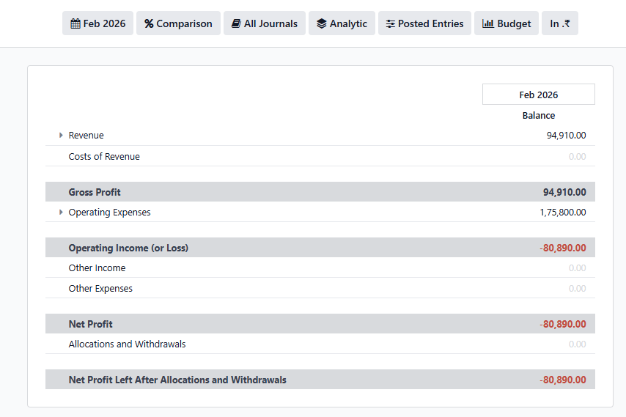
Profit and Loss report for the selected company or branch
Similarly, we can view all other financial reports for every branch or company either individually or combined.

Part 6 — Viewing Inventory Reports by Warehouse

Current Stock by Warehouse
To see the stock available at each warehouse for a company, open the inventory report of the company and group by warehouse.
Inventory App → Reporting → Stock → Select the Warehouses to view its products
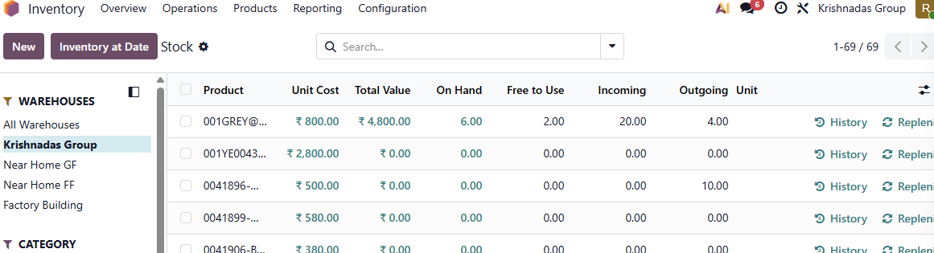
Inventory report for the selected warehouse

Stock Moves History

Inventory App → Reporting → Stock Moves
Group by destination location to see stock movement involving a specific warehouse.

Part 7 — Viewing Sales Reports by Company

To analyze sales performance for each company, First select all the companies from company selector. Now open sales report and group by Company. Use pivot view for better understanding
Sales App → Reporting → Sales → Group by Company
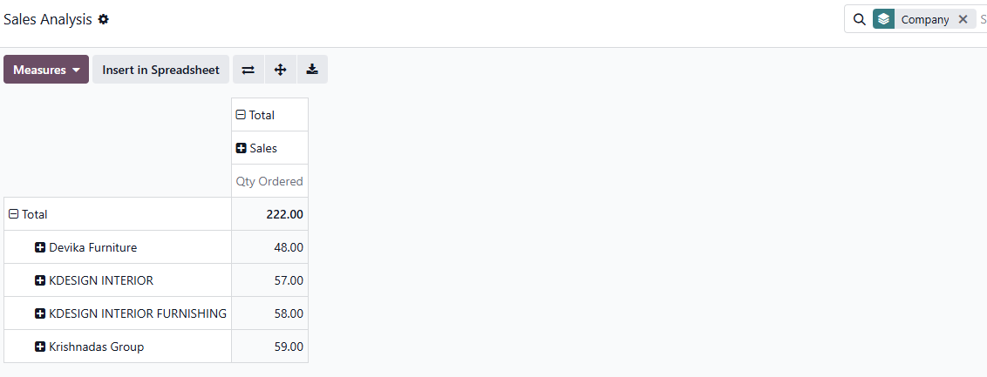
sales report of companies and branches grouped by company

As the business grows, Odoo 19 allows us to seamlessly add more companies, branches, and warehouses within the same system. Each entity can be managed independently while still enabling consolidated reporting, ensuring full visibility and control at both branch and company levels.

